Brussels Conference on Afghanistan

<http://www.akdn.org/speech/his-highness-aga-khan/brussels-conference-afghanistan>

Statement by His Highness the Aga Khan at the Brussels Conference on Afghanistan

Bismillah-ir-Rahman-ir-Rahim  
Your Excellency Federica Mogherini and  
Your Excellency Salahuddin Rabbani;  
Excellencies, Ladies and Gentlemen

I thank the Government of Afghanistan and the European Union for bringing the international community together.  I am very pleased to be here, as the Ismaili Imamat and the Aga Khan Development Network have an enduring commitment to Afghanistan.

Since 2001, AKDN and its partners have channelled over $1 billion to enhance self-reliance and improve the quality of life of Afghans.  Between now and 2020, AKDN plans similar investments in cultural heritage, education, energy, health, and poverty alleviation.

In supporting the Afghanistan National Peace and Development Framework, I wish to highlight three areas we believe are crucial to its success.

First, it is urgent to drive efforts to sustain and develop Afghanistan’s human and social capital. For this purpose, AKDN supports the Ministry of Education’s National Education Strategic Plan in over 850 schools and education centres.  In health, AKDN’s public private partnerships have provided treatment to over 1.6 million Afghans and trained over 13,000 doctors, nurses, and health workers. Together with our partners, we will soon inaugurate the Mothers and Children’s wing of the French Medical Institute in Kabul and the new Bamiyan Provincial Hospital.

Second, supporting civil society is essential. Decades of experience have taught us that effective civil society is fundamental to lasting progress, helping ensure development that is inclusive and participatory.  Civil society can unleash constructive talents from a broad spectrum of organisations and individuals, including the private sector.   We are gratified to see these principles reflected in the Citizen’s Charter adopted last week by the government.

Third, area development should be supported. Ensuring sustained social and economic gains often requires working across frontiers.  One promising example is Pamir Energy, a public private partnership between the Aga Khan Fund for Economic Development and the Government of Tajikistan.  Since 2008, it has exported electricity across the border, reaching nearly 35,000 Afghans, and much more is possible.

Finally, I would reiterate my profound belief in the power of sustained, long-term, multi-dimensional development that empowers individuals and communities to improve their quality of life.  It is with that conviction that I support this meeting and reconfirm our commitment to Afghanistan’s future.

Thank you.

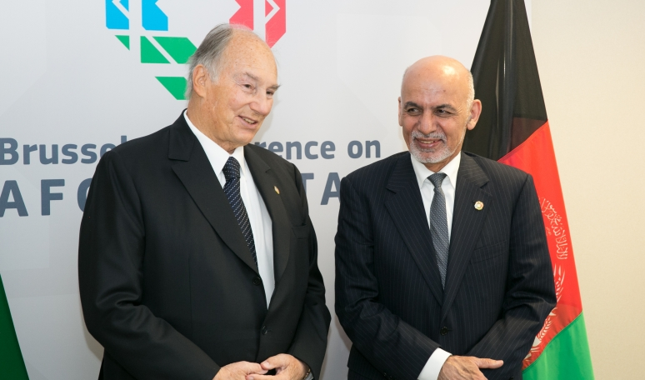

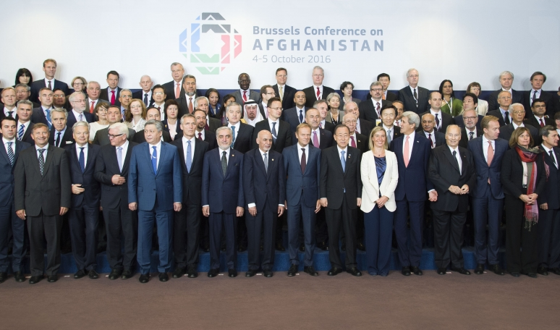

Delegates at the Brussels Conference on Afghanistan

European Union